No. 4-423

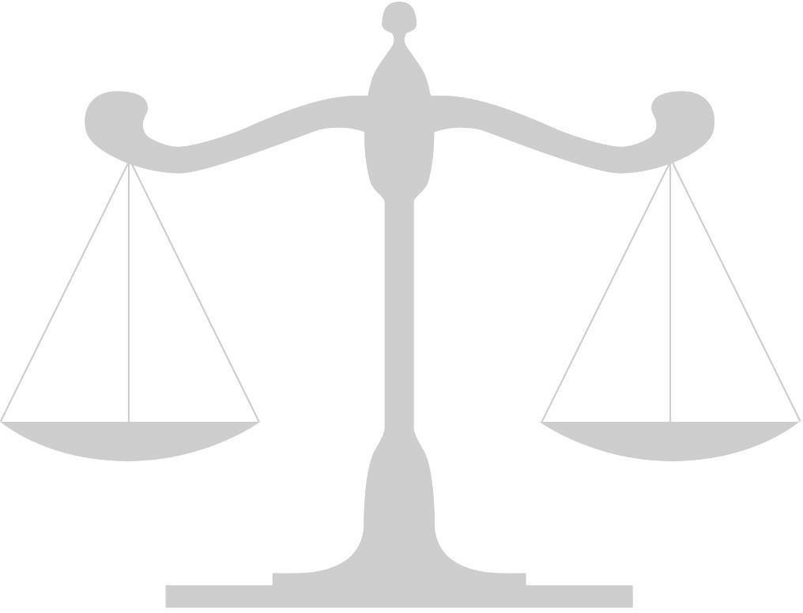
IN THE

Supreme Court of the United States

Elijah Casey

v.

Petitioner,

The State of Texas,
Respondent.

On Writ of Certiorari to
the Texas Court of Criminal Appeals

Bench Brief

Judge Name
School Name or YMCA Delegation

