No. 4-423

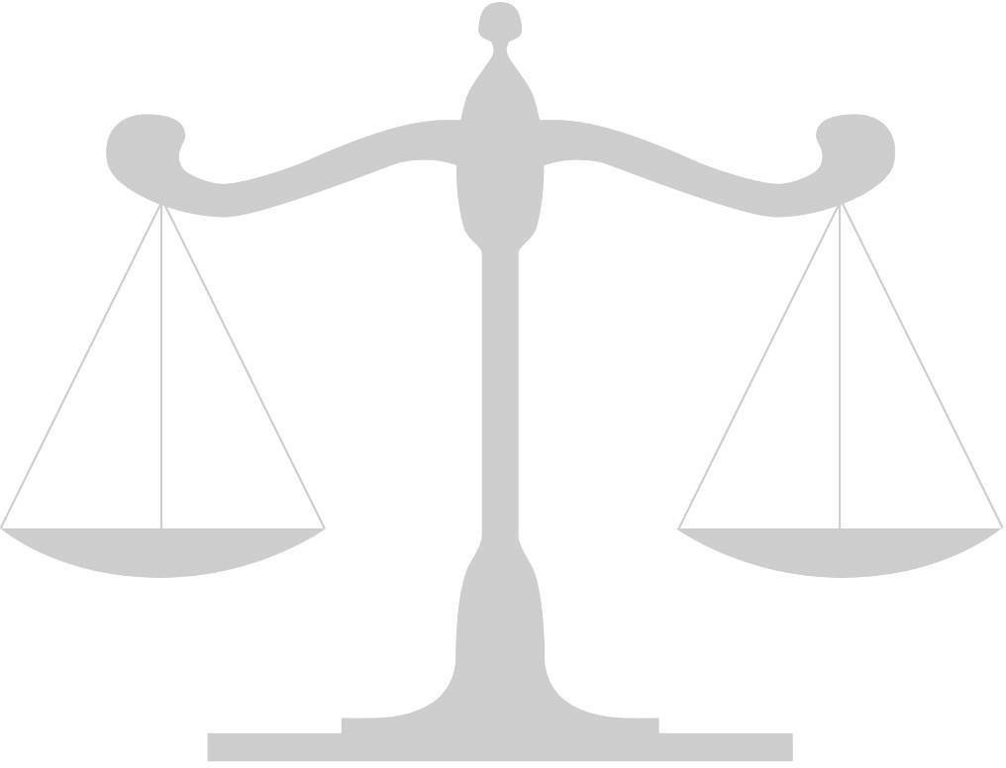
IN THE

Supreme Court of the United States

Elijah Casey

v.

Petitioner,

The State of Texas,
Respondent.

On Writ of Certiorari to
the Texas Court of Criminal Appeals

Brief for Appellee

Name (Attorney #1)
Name (Attorney #2)
School Name or YMCA Delegation

No. 4-423

IN THE

Supreme Court of the United States

Elijah Casey

v.

Petitioner,

The State of Texas,
Respondent.

On Writ of Certiorari to
the Texas Court of Criminal Appeals

Brief for Appellant

Name (Attorney #1)
Name (Attorney #2)
School Name or YMCA Delegation

