No. 4-423

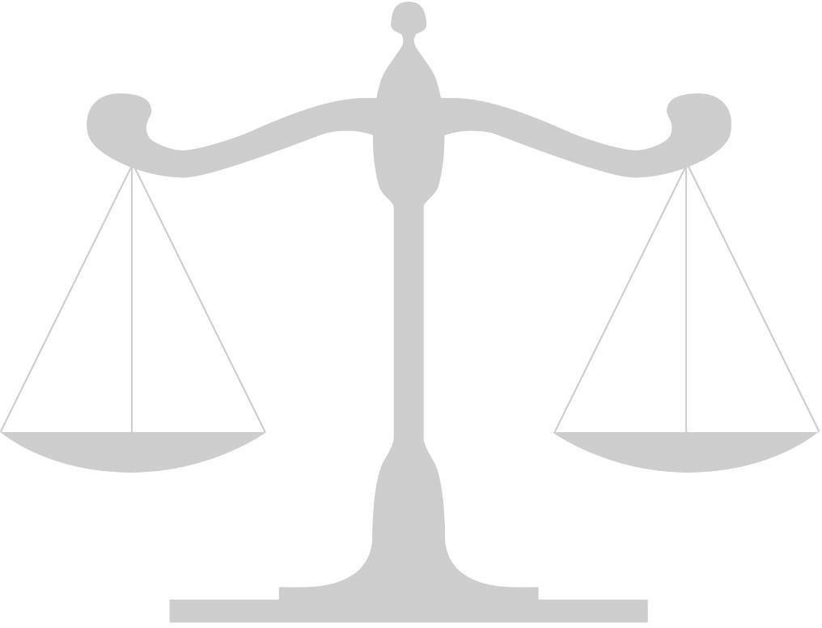
IN THE

Supreme Court of the United States

Larry Bridges

v.

Petitioner,

The State of Texas,
Respondent.

On Writ of Certiorari to
the Texas Court of Criminal Appeals

Brief for (Appellee or Appellant)

Name (Attorney #1)
Name (Attorney #2)
School Name or YMCA Delegation

