No. 4-422

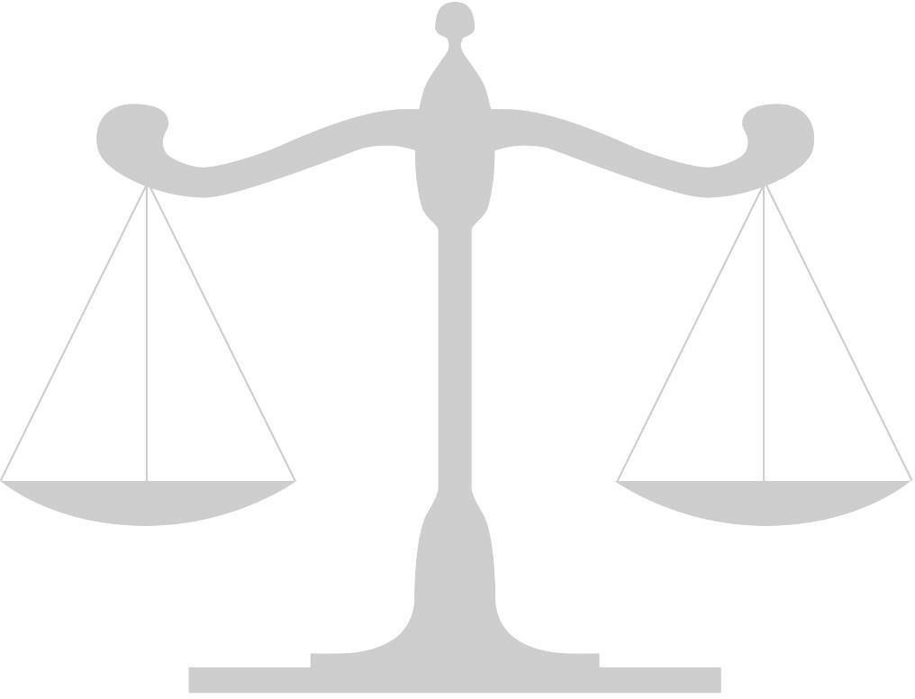
IN THE

Supreme Court of the United States

Chad David,

v.

Petitioner,

The United States of America,
Respondent.

On Writ of Certiorari to
the United States Court of Appeals for the Thirteenth Circuit

Brief for (Appellee or Appellant)

Name (Attorney #1)
Name (Attorney #2)
School Name or YMCA Delegation

