YMCA Texas Youth and Government

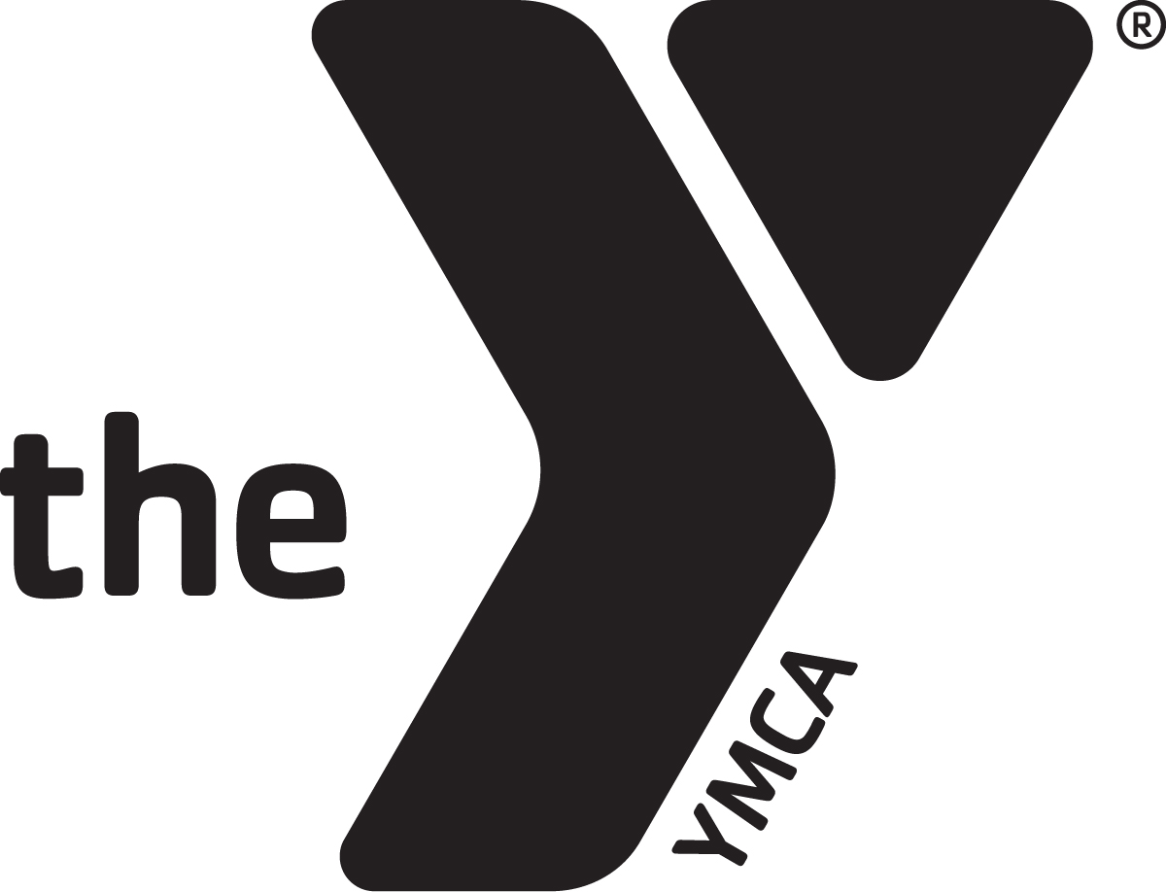
2020-21 PROGRAM REGISTRATION
YMCA Branch: | DISTRICT:

participant INFORMATION
Last Name:  First Name: |  | Middle Name: |  | Select One: ☐Student ☐Adult Volunteer  ☐YMCA Staff  Select One:  ☐New Participant ☐Returning Participant
Gender:
☐Female ☐Male
Participant Home Phone:  Participant Mobile Phone: | Address:  City:  State: Zip Code: |  | Birth date:  00/00/YEAR |  | Number of years in YG:___  Attended State Conference  last year: ☐Yes ☐No
Email: I understand communication will be sent via email: ☐Yes ☐No
Select: ☐African American ☐Asian ☐Caucasian ☐Latino/Hispanic ☐Native American ☐Pacific Islander
Select T-Shirt Size (all adult sizes): ☐XXS ☐XS ☐Small ☐Medium ☐Large ☐XL ☐2XL ☐3XL ☐4XL ☐5XL
Dietary preferences (program is nut- and pork-free): ☐No specific diet ☐Gluten free ☐Vegetarian ☐Vegan ☐Dairy free
If you are a returning participant, indicate number of years you have been in Youth and Government: ______
Last year I participated in the following:☐High School YG ☐Junior YG ☐Both ☐None
MEDICAL/ALLERGIES: List all medical conditions, allergies and/or daily medication we need to be aware of. If you do not have any, indicate in the space (NONE):
STUDENT ONLY INFORMATION
School: | Grade: ☐6 ☐7 ☐8 ☐9 ☐10 ☐11 ☐12 | Student lives with:
Section: | Do you intend to run for office? | If yes, which position?
Parent/Guardian Name #1:  _________________________________  Birth date: 00/00/YEAR  ☐Mother ☐Father ☐Legal Guardian  Custodial Parent: ☐Yes ☐No | Complete Mailing Address if different from student: | Home Phone:  Mobile Phone:  Email:  YG Alumni ☐Yes ☐No
Parent/Guardian Name #2:  _________________________________  Birth date: 00/00/YEAR  ☐Mother ☐Father ☐Legal Guardian  Custodial Parent: ☐Yes ☐No | Complete Mailing Address if different from student: | Home Phone:  Mobile Phone:  Email:  YG Alumni ☐Yes ☐No
ADULT PARTICIPANT ONLY Indicate school if club advisor: First Year Club Advisor? ☐Yes ☐No

IN CASE OF EMERGENCY FOR ALL PARTICIPANTS
Name of contact:
Relationship to participant: Email:
Home phone: Mobile phone: Work phone:
AUTHORIZATION and ACKNOWLEDGMENT: By my signature, and of my free will I assume all risks and hazards incidental to this program/event. I do further release, absolve, indemnify and hold harmless, now and for all time, YMCA of Austin, the sponsoring YMCA, the organizers, sponsors, supervisors, volunteers and their agents, board of directors, representatives or assignees (collectively “The Parties”). I hereby waive all claims, now and for all time, against the Parties, for any injury to myself/my child any loss due to theft of or damage to his/her personal property or for any other consequential or incidental damages caused in any manner whatsoever where any such liability is attributable to the absence of ordinary or even slight care by the program/event organizers and the conduct of this program/event. The YMCA is hereby granted permission to use any individual or group photographs and/or videotapes showing me/my child in YMCA activities for use in public relations, promotional or advertising purposes. The YMCA has my permission to transport me/my child to, from, and during YMCA sponsored events/activities. In the event I cannot be reached or unable to make arrangements for emergency medical attention, I authorize the YMCA staff to take me/my child to the nearest hospital/clinic for treatment or to the one below: Physician/Hospital/Clinic: _____________________________ Address_______________________________ Phone# ________________ I give consent for all necessary treatment for myself/my child when in the care of this physician and/or hospital/clinic.
 | Signature of Legal Guardian/Adult Participant, if 18 or over |  | Date

CODE OF CONDUCT Youth & Adults
As a member of a YMCA sponsored program and in conformity with the basic purpose of the YMCA, I agree with and will observe the following principles as my personal code of conduct while attending any of the YMCA sponsored events.
Please read and sign the form, acknowledging you have reviewed the conduct codes :
- I understand that violations of the Code of Conduct will result in disciplinary actions by YMCA Staff and/or appropriate legal authority depending on seriousness of the infraction (i.e. drugs, alcohol, shoplifting, etc.).
- Disciplinary actions may also include expulsion from the program and being sent home at your own expense.
- I will conduct myself at all times in a way, which reflects good conduct and sense of responsibility, remembering the YMCA values: respect, responsibility, caring and honesty.
- If I create Social Media sites OR post to Social Media sites that reference YMCA and/or Youth & Government, I agree to follow the same YMCA values as stated above. Any form of bullying, including Cyber Bullying will not be tolerated.
- Rest is most important to maximum participation; therefore, it is important that I observe all curfews on overnight events/conferences.
- The use and/or possession of alcohol, firearms, tobacco, or illegal drugs are against all standards implied in our principles and are prohibited. Therefore, I agree not to bring, obtain, possess or use them en-route to, during, or returning home from the Conference/event.
- I agree to help all delegates, regardless of race, gender, religion, national origin or disability, to feel welcome and to protect their rights to full participation.
- I agree to avoid violations and violators. While not always fair, I could be held accountable for the actions of those I am with -- often referred to as "guilt by association".
- In order to complete our agendas, I will be present and punctual at all meetings/events. Any exceptions should be cleared and documented with my Advisor, YMCA Staff and/or District Director in advance of the Conference.
- My greatest respect will be given to the facilities that we use for our program.
- I will not visit in other delegates’ lodging rooms. Visiting will be done in the Lobby/common area only.
- An adult cannot enter a student’s room by themselves. Adult must have another authorized adult with them in order to go in to a room that requires the need to enter it.
- For emergencies only, when getting an ambulance or a YMCA authorized vehicle is not an option: Authorized adult may transport delegate in personal vehicle only if another authorized adult is in the car AND prior approval has been obtained from guardian, District Director and/or State Director. I understand that the driver’s personal vehicle insurance will be used in case of an accident. YMCA Risk Management Department must be notified.
- I will abide by the set Dress Codes for any YMCA YG meetings/events/conferences.
- I will abide by the Pre-Conference Handbook and Delegate handbook.
- I understand that any violation of the above can result in suspension or expulsion from the program. No refunds will be
- made.
Behavior Policy Statement
The YMCA reserves the right to warn, suspend, dismiss or remove any program participant or member from our programs, program locations and facilities upon the following conditions:
- If their behavior poses a threat to themselves or others.
- If they require an inordinate amount of attention from the staff thereby causing inadequate levels of supervision for the remainder of the participants or members.
- If their behavior is determined to be inappropriate within the scope and spirit of the YMCA values.
- For any reason within the discretion of YMCA management
If your teen is removed from the program for any of the above reasons, you must retrieve your teen at your expense.

DELEGATE NAME AND SIGNATURE

Print Name: _________________________________________________________
Signature Date
PARENT/GUARDIAN NAME AND SIGNATURE

Print Name: ___________________
Signature Date

