AMELIE HODGE’S FORENSIC FILES:

THE CASE OF
“THE FAITH HEALING FATHER”
STATE OF TEXAS VS.
DON COLESON
Virtual Summer 2020 Competition Trial Court Case

Case Materials Written By:
Ashley Myrick
Nathan Capper
Table of Contents
List of Witnesses and Documentary Evidence… 3
Sworn Complaint 4
Search Warrant 5-6
Search Warrant Evidence Ledger… 7
Jury Instructions… 8-11
Witnesses for the Prosecution
Detective Hodge’s Police Report… 12-15
Kate Riley’s Witness Statement 16-17
Dr. Joshua Sapp’s Witness Statement 18-19
Witnesses for the Defense
Don Coleson’s Witness Statement 20-22
Rev. Shorty McGee’s Witness Statement 23-25
Diane Reagan’s Witness Statement 26-27
Madeline Coleson’s Witness Statement 28-29
Exhibits… 30
Emails… 31
Teacher’s Notes… …32-33
Photo of Annabelle Coleson… 34
Autopsy Report 35-37

LIST OF WITNESSES AND DOCUMENTARY EVIDENCE TO BE USED IN THIS CASE

WITNESSES FOR THE PROSECUTION, STATE OF TEXAS:
- Detective Amelie Hodges
- Kate Riley
- Dr. Joshua Sapp

WITNESSES FOR THE DEFENDANT, DON COLESON:
- Don Coleson
- Diane Reagan
- Reverend Shorty McGee
- Madeline Coleson

***You may only call three witnesses for the defense***

Documents included in the packet:
- Complaint
- Search Warrant
- Jury Instructions
- Police Report
- Witness Statements
- Applicable statutes

Potential Physical Evidence
- E-mails
- Notes from teacher (Kate Riley) to Don Coleson
- Photograph of Annabelle Lee Coleson
- Autopsy Report

CASE NO. 20-123456

STATE OF TEXAS | § | IN THE 1st DISTRICT COURT
 | §
vs | §
 | §
DON COLESON | § | COCO COUNTY, TEXAS

SWORN COMPLAINT

Complainant, on information and belief, being first duly sworn on oath states that:

Count 1: Manslaughter in the second degree:
The above-named defendant on or about Friday, January 31, 2020, in the City of Brookbend, Texas, did recklessly cause the death of Annabelle Lee Coleson, contrary to Texas Penal Code, Section 19.04 which is a second degree felony, and upon conviction may be fined not more than $10,000 and/or imprisoned not more than 20 years or less than 2 years.

Count 2: Second Degree Injury to a Child:
In the alternative, the above-named defendant on or about Friday, January 31, 2020, in the City of Brookbend, Texas did recklessly cause serious bodily injury to a child to wit the death of Annabelle Lee Coleson, contrary to Texas Penal Code, Section 22.04 which is a second degree felony, and upon conviction may be fined not more than $10,000 and/or imprisoned for not more than 20 years or less than 2 years.

Complainant is a law enforcement officer in Brookbend, Texas and bases this complaint upon the attached law enforcement reports which your complainant believes are reliable in that they are made by the officer in the routine and ordinary course of the officer’s official duties.

Your complainant believes the statements contained within said reports are reliable for the following reasons: They are made by Diane Reagan, Kate Riley, Rev. Shorty McGee and Madeline Coleson, as witnesses to activity, insofar as it is based upon personal observations and knowledge. They are made by Dr. Joshua Sapp based upon his specialized expertise. They are made by Don Coleson contrary to penal interests.

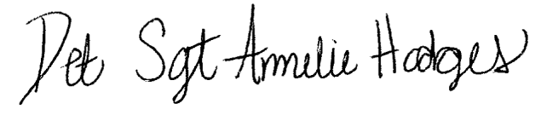
And prays that the defendant be dealt with according to law.

X
Complainant – Det. Sergeant Amelie M. Hodges

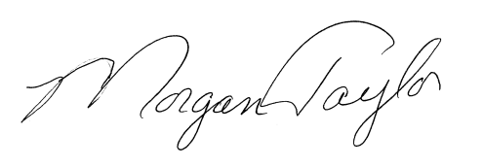
Subscribed and sworn to before me, And approved for filing on this: February 25, 2020

X
Morgan Taylor - District Attorney Coco County, Texas
State Bar Number: 0134556782

SEARCH WARRANT

STATE OF TEXAS §
§
§ 1st DISTRICT COURT
§
COCO COUNTY, TEXAS §

THE STATE OF TEXAS, to Detective Sergeant Amelie M. Hodges, Brookbend Police Department or any constable or any peace officer of said county:
WHEREAS, Detective Sergeant Amelie Hodges being duly sworn says that on the 31st day of January 2020, in the City of Brookbend, the State of Texas, in and upon certain premises located at 111 Penny Park Place, occupied by Don Coleson, Madeline Coleson and Annabelle Coleson, and more particularly described as follows:
A one-story house. There are double garage doors located on the north side of the house. There is a single brown front door to the house which is also located on the north side of the house. The roof of the house is black. There are white shutters on the home and the siding is dark green. There is a number affixed to the side of the house identifying it as number 111 Penny Park Place. There are now located and concealed upon these premises certain things which constitute evidence of a crime, possessed for the purpose of evading or violating the laws of the State of Texas and contrary to Texas Statutes, which things may constitute evidence of a crime, to wit the criminal homicide of Annabelle Lee Coleson which things were used in the commission of a crime, to wit:
Medical supplies including but not limited to syringes, medications, medical books, bedding used by the victim, clothing worn by the victim, religious books, religious videos, religious pamphlets, diaries, journals, logs, computers and computer files, computer hard drives, computer disks, computer zip drives and computer print outs.
AND PRAYED that a search warrant be issued to search said home.
NOW, THEREFORE, in the name of the State of Texas, you are commanded forthwith to search said home for said things and if the same, or any portion thereof, are found, to bring the same and return this warrant after execution before this court, or before any court of record for Coco County, to be dealt with according to law.
Said warrant must be executed not more than three (3) days after the date of issuance and returned not more than 48 hours after execution thereof.
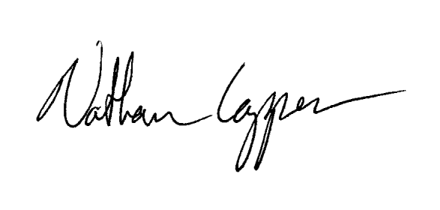
Dated this the 2nd day of February 2020.

BY THE COURT:

X
Nathan Capper - District Judge

ENDORSEMENT ON WARRANT

Received by me this 2nd day of February, 2020 at 1:00 p.m.

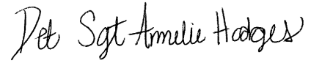
X
Det. Sergeant Amelie Hodges

I hereby certify that by virtue of the within warrant I searched the within named premises and found the following items:

See attached copy of evidence ledger

And have the same now in my possession subject to the direction of the court.

Dated this 4th day of February 2020.

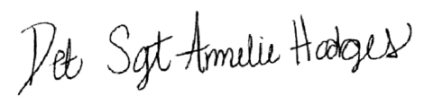

Det. Sergeant Amelie Hodges
X

Brookbend Police Department Search Warrant Evidence Ledger

Case #: 20-123456 | Report Date: February 4, 2020 |  |  | Date & Time Obtained: February 4, 2020
Items taken from: ⃝ Person |  | ⃝ Vehicle | X ⃝ Scene ⃝ Other
How seized: ⃝ Incident to Arrest |  | ⃝ Voluntary | X ⃝ Search Warrant ⃝ Other
Scene location or address: 111 Penny Park Place, Brookbend, Texas
Person Name: Don Coleson |  |  | Owner: X ⃝ Yes ⃝ No

DESCRIPTION OF ARTICLES
1 | Physicians of Death book by Rev. Shorty McGee
2 | Assorted CDs by Rev. Shorty McGee on healing by faith
3 | Box for 12 syringes (1 syringe missing/11 in box)
4 | Raised from the Dead by Rev. Shorty McGee
5 | 3 Bibles, King James Version
6 | Guidebook to Healing by Rev. Shorty McGee
7 | Two notes from Kate Riley to Don Coleson
8 | Manila folder with insurance paperwork
9 | Toshiba laptop computer
10 | Squirt top water bottle with liquid
11 | Used syringe with liquid
12 | Information on the afterlife printed off the internet
13 | E-mail printout between Don Coleson and Rev. Shorty McGee dated January 29, 2020
14 | Bedclothes from Annabelle Coleson’s room
15 | Various clothing items of Annabelle Coleson

Chain of Custody
Released By | Received By | Purpose of Change of Custody/Location
Signature:  Name, Title: N/A Date: | Signature: 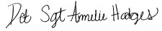  Name, Title: Det. Sergeant Amelie M. Hodges  Date: 2/4/2020 | Evidence secured in Brookbend Police Department evidence locker

Jury instructions for State v. Don Coleson

In addition to standard instructions addressing such matters as the burden of proof on the State, the requirement of proof beyond a reasonable doubt and the need for jury unanimity, the following special jury instructions are appropriate for this case:

DEFINITIONS
INSTRUCTION NO. 1:

A person acts recklessly, or is reckless, with respect to circumstances surrounding his conduct or the result of his conduct when he is aware of but consciously disregards a substantial and unjustifiable risk that the circumstances exist or the result will occur. The risk must be of such a nature and degree that its disregard constitutes a gross deviation from the standard of care that an ordinary person would exercise under all the circumstances as viewed from the actor's standpoint. (Texas Penal Code § 6.03(c)).

- “Serious bodily injury” means bodily injury that creates a substantial risk of death or that causes death, serious permanent disfigurement, or protracted loss or impairment of the function of any bodily member or organ. (Texas Penal Code § 1.07 (46))

Child means a person 14 years of age or younger.

- Omission means failure to act.

MANSLAUGHTER

INSTRUCTION NO. 2:
A person commits the crime of manslaughter in the second degree if he recklessly causes the death of an individual. (Texas Penal Code § 19.04)

INSTRUCTION NO. 3:

Now, bearing in mind the foregoing instructions, if you find from the evidence beyond a reasonable doubt that on or about January 31, 2020 in Brookbend, Texas, the defendant, Don Coleson did recklessly cause the death of Annabelle Lee Coleson, you will find the defendant guilty of the offense of manslaughter as alleged in the indictment.

If you do not so find, or if you have a reasonable doubt thereof, you will find the defendant not guilty.

INJURY TO A CHILD

If, after full and careful deliberation of the charges of manslaughter in the second degree, you are not unanimously satisfied beyond a reasonable doubt that the defendant is guilty of this charge,

then you may consider whether the defendant has been proven to be guilty of the lesser crime of injury to a child.

INSTRUCTION NO. 4:

A person who has a legal duty to act commits the crime of injury to a child if he recklessly by omission, causes a child serious bodily injury. (Texas Penal Code § 22.04 (a))

A parent of a child has the duty to support the child, including providing the child with clothing, food, shelter, medical and dental care, and education. (Texas Family Code § 151.001 (a)(3)).

AFFIRMATIVE DEFENSE

INSTRUCTION NO. 5:

It is an affirmative defense to injury to a child that the omission was based on treatment in accordance with the tenets and practices of a recognized religious method of healing with a generally accepted record of efficacy.

The burden of proof is on the defendant to prove such a defense by a preponderance of the evidence. The term "preponderance of the evidence" means the greater weight of the credible evidence.

INSTRUCTION NO. 6:

Now, bearing in mind the foregoing instructions, if you find from the evidence beyond a reasonable doubt that on or about January 31, 2020 in Brookbend, Texas, the defendant, Don Coleson did recklessly by omission, cause serious bodily injury to Annabelle Lee Coleson and you find that the defendant failed to prove his affirmative defense by a preponderance of the evidence, you will find the defendant guilty as charged in the indictment.

If you find that the defendant did not by omission recklessly cause serious bodily injury to Annabelle Lee Coleson or you have a reasonable doubt thereof, or if you find by the preponderance of the evidence that the omission was based on treatment in accordance with the tenets and practices of a recognized religious method of healing with a generally accepted record of efficacy, then you will find the defendant not guilty.

INSTRUCTION NO. 7:
The evidence that has been presented to you may be either direct or circumstantial. The term "direct evidence" refers to evidence that is given by a witness who has directly perceived something at issue in this case. The term "circumstantial evidence" refers to evidence from which, based on your common sense and experience, you may reasonably infer something that is at issue in this case. The law does not distinguish between direct and circumstantial evidence in terms of their weight or value in finding the facts in this case. One is not necessarily more or less valuable than the other.

APPLICABLE TEXAS STATUES

Penal Code: Sec. 19.04 - Manslaughter

A person commits an offense if he recklessly causes the death of an individual.

- An offense under this section is a felony of the second degree.

Penal Code: Sec. 22.04 - Injury to a Child

A person commits an offense if he… recklessly by act or recklessly by omission, causes to a child:

  - serious bodily injury;

An omission that causes a condition described by Subsection (a)(1) is conduct constituting an offense under this section if:

  - the actor has a legal or statutory duty to act;

In this section:

  - "Child" means a person 14 years of age or younger.

(e) When the conduct is engaged in recklessly, the offense is a felony of the second degree.

k) (2) It is an affirmative defense to prosecution under this section that the act or omission was based on treatment in accordance with the tenets and practices of a recognized religious method of healing with a generally accepted record of efficacy.

Code of Criminal Procedure: Art. 18.01. Search Warrant

No search warrant shall issue for any purpose in this state unless sufficient facts are first presented to satisfy the issuing magistrate that probable cause does in fact exist for its issuance. A sworn affidavit setting forth substantial facts establishing probable cause shall be filed in every instance in which a search warrant is requested.

- A search warrant may not be issued pursuant to Subdivision (10) of Article 18.02 of this code unless the sworn affidavit required by Subsection (b) of this article sets forth sufficient facts to establish probable cause:

that a specific offense has been committed,

  - that the specifically described property or items that are to be searched for or seized constitute evidence of that offense or evidence that a particular person committed that offense,

and

  - that the property or items constituting evidence to be searched for or seized are located at or on the particular person, place, or thing to be searched.

Brookbend Police Department
Initial Police Report

Case #: 20-123456 | Report Date: February 14, 2020 | Page Number: 1 of 4
SYNOPSIS:
Annabelle Coleson (age 4) died at her residence of 111 Penny Park Place in the City of Brookbend as a result of medical complications. This case will be marked active and the investigation will continue.

On January 31, 2020 at 3:56 p.m. dispatch requested that Officer Myrick respond to 111 Penny Park Place in the City of Brookbend for a report of unknown medical problems with a four year old female. Dispatch further paged out Brookbend Ambulance Service to respond to the scene as well. Dispatch received information from a female in Fort Worth who stated that one of her students was ill and due to religious reasons, the father would not take the child to the hospital for treatment. The caller further advised dispatch that she believed the child had had very shallow breathing, was running a high fever, was extremely weak and pale and that she feared the child was in or near a coma at the time of her call.

I responded to the area as well and while in route to that address, dispatch advised that they had just received a 911 call from the residence of 111 Penny Park Place, stating that the child was now without a pulse and was no longer breathing.

I was the first to arrive on scene and upon entry into the residence there were numerous people sitting in the living and dining room. I was directed to a bedroom in the back of the house where I observed a 4-year-old female lying on a blanket on the floor of the room. I observed a man (later identified as the child’s father) attempting to push down on the girl’s chest as I came into the room. The father was
praying to God at the time I came into the room. There were several other adult males in the room also praying. The Brookbend Emergency Personnel entered the room right behind me and immediately hooked the girl up to the defibrillation unit. The girl lying on the mattress had her eyes open and was still warm at the time of our arrival. I picked up the 4-year-old girl and took her out to the cot in the ambulance where she was immediately loaded up and transported to Brookbend Hospital.

Once at Brookbend Hospital, Emergency Personnel attempted to revive Annabelle for approximately 30 to 45 minutes but those attempts were unsuccessful and Annabelle was pronounced dead at Brookbend Hospital at 4:50 p.m.
At this time while in the privacy of a room outside the Emergency Room Department, I spoke with Don Coleson, the father of Annabelle. As I spoke with her father, he advised that Annabelle had not been sick at all over the past couple of days. It was extremely difficult to get any information from the father about any medical problems Annabelle was experiencing. He advised that Annabelle had not been eating or drinking and that she was unable to talk or walk from Tuesday, January 28, 2020 through today.

Brookbend Police Department
Initial Police Report

Case #: 20-123456 | Report Date: February 14, 2020 | Page Number: 2 of 4
Mr. Coleson stated that it appeared as if Annabelle was in a coma starting this afternoon where she was unable to move, walk or talk in any way. Mr. Coleson stated that he placed Annabelle on the blanket just before I had arrived.
As I attempted to speak with the father, Annabelle’s sister Madeline (age 9) began providing me with information about how Annabelle had been feeling over the last couple of days. She stated that Annabelle had not been eating or drinking and that the last time she heard her say anything as far as words, was yesterday before dinner. After dinner Annabelle had laid down and was unable to move her mouth and would only make moaning sounds. As Madeline provided me this information, the father acknowledged that it was correct but would not provide any additional details about how sick Annabelle had been.

Shortly after this interview, the father was informed by the Emergency Room Physician that Annabelle had died. I further interviewed Mr. Coleson on February 7, 2020 and Mr. Coleson provided me with a written statement at that time. The information contained in his statement was similar to the information he provided to me at the hospital.

On February 2, 2020, I made contact with the reporting party from Fort Worth, Kate Riley who was
Annabelle’s school teacher.

In speaking with Ms. Riley, she advised the following: She stated that she felt Annabelle had been sick for at least two or more weeks and had not been talking or as active or eating at least part of this time. During this time she stated that she did have the chance to speak with Madeline and Mr. Coleson about Annabelle being sick and that this is how she learned some of her information. According to Ms. Riley, she sent two notes home regarding Annabelle’s condition and approximately a week ago she spoke with Mr. Coleson on the phone and expressed her concerns and the need to take Annabelle to a doctor. Mr. Coleson told Ms. Riley that he thought it might just be a growth spurt and he was sure that Annabelle would be okay. Ms. Riley told him that she was very concerned about Annabelle and that she did not believe it was just a growth spurt. She told Mr. Coleson that since Annabelle was not eating or drinking, that at a minimum, Annabelle needed to get Pedialyte in order to maintain nutrients in her body. Mr.
Coleson told her that to give Annabelle Pedialyte or any sort of medication or medical care would be taking away the glory from God and that he would not provide Annabelle any such care. Mr. Coleson told Ms. Riley at that time “Annabelle will be fine. God will heal her.” Ms. Riley told me that Mr.
Coleson does not believe in doctors and will not take either child to the doctor for any check-ups or shots.
Ms. Riley also spoke to Madeline who told her that Annabelle had been acting like this for several days
and mostly didn’t want to get out of bed, play, eat or drink.

Brookbend Police Department
Initial Police Report

Case #: 20-123456 | Report Date: February 14, 2020 | Page Number: 3 of 4
On January 31, 2020 at approximately 3:45 p.m., Ms. Riley called the Coleson home when Annabelle did not come to school that day. She was told that Annabelle was in a coma state when she called and spoke to Annabelle’s sister Madeline. It was at this time that she called dispatch to report the situation. She advised dispatch that she understood that Mr. Coleson was putting water into Annabelle’s mouth with a syringe and was worried that Annabelle could not swallow any of the water being given to her and might choke.
Ms. Riley provided me a written statement. Copies of the notes that Ms. Riley wrote to Mr. Coleson were found during the search of the Coleson house.
On February 8, 2020, I spoke to a friend of Mr. Coleson’s by the name of Diane Reagan who told me that on Monday morning, January 31, 2020, Mr. Coleson called her and stated that Annabelle was in a coma state but was still breathing. Mr. Coleson told Diane that Annabelle had not been running a fever and had never complained of being sick. Mr. Coleson asked Diane what he should do because Annabelle seemed to be very dehydrated. Diane advised him to use a syringe to put water into Annabelle’s mouth. Diane Reagan is a member of Mr. Coleson’s church. Ms. Reagan arrived at the Coleson house in the morning and stayed throughout the day. According to Ms. Reagan, various church members came to the home as did the pastor and they prayed throughout the day. At one point Ms. Reagan suggested that EMS be called to transport Annabelle to the hospital; however, both Mr. Coleson and the pastor told her no.

Ms. Reagan provided me with a written statement.

On February 9, 2020, I spoke with Madeline Coleson. Madeline provided me with information regarding Annabelle’s condition over the past two weeks. According to Madeline, the Coleson family did not believe in obtaining professional medical care.
Madeline Coleson provided me a written statement.

On February 9, 2020, I interviewed Reverend Shorty McGee. Rev. McGee provided me with information regarding the religious beliefs of his church regarding professional medical care. Rev. McGee also provided me with information regarding the events which occurred on January 31, 2020 surrounding the death of Annabelle Lee Coleson. Rev. McGee and Don Coleson had corresponded prior to January 31, 2020 about Annabelle’s medical condition. Copies of the e-mails were recovered during the search of the Coleson house.

Rev. McGee provided me a written statement.

Brookbend Police Department
Initial Police Report

Case #: 20-123456 | Report Date: February 14, 2020 | Page Number: 4 of 4
It should be noted that in looking at Annabelle’s physical appearance, on January 31, 2020, she appeared to be extremely malnourished and very thin. Her sister Madeline appeared to be healthy and did not appear to be neglected in any way.
I spoke with the physician who attended Annabelle in the emergency room and he stated that
Annabelle’s blood sugar level was very high to the point that no reading could be obtained. It appeared that she was diabetic but had never been diagnosed with the disease because she had not seen a doctor since birth.

Medical Examiner Joshua Sapp responded to the call to the hospital and stated that he would be performing an autopsy. The autopsy was performed and Dr. Sapp provided a written autopsy report and a written statement regarding Annabelle’s medical condition.
On February 4, 2020 at 1:00 p.m., a search warrant was served on the Coleson home at 111 Penny Park Place, Brookbend, Coco County, Texas 76126 on February 4, 2020. One of the items recovered is an e- mail which was found on the desk in the office area of the home. The e-mail which was printed on a piece of paper has two separate e-mails on it. When you look at the e-mails, the top e-mail is dated January 29, 2020 at 4:45 p.m. The lower e-mail is dated January 29, 2020 at 3:00 p.m. In reviewing this document, it is very apparent that at least by Wednesday, January 29, 2020 at 3:00 p.m., Don Coleson was aware of the fact that his daughter was very ill and that he was reaching out for emergency prayer to help his daughter. However, it is difficult to understand how Mr. Coleson failed to notice how sick his daughter was for almost two weeks before her death.

RECOMMENDATION:
Refer to the District Attorney’s office for prosecution for Criminal Homicide and Injury to a Child

Detective Sergeant Amelie M. Hodges, #11
*Detective Sergeant with the Brookbend Police Department (2014 to 2020 – Homicide Division; 2009 to 2014 – Armed Robbery)

*Patrol Officer with the Brookbend Police Department (2006 to 2009)
*Graduate of the Brookbend Police Academy

*BA in Criminal Justice from University of Texas at Arlington

Officer Signature & Date  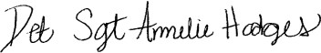  Det. Sergeant Amelie M. Hodges | Report Approved By:  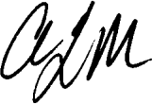 | Date Approved: February 14, 2020

Brookbend Police Department
Witness Statement

Case #  20-123456 | Date of Report:  February 2, 2020 | Case Title:  Coleson Child Death
Activity: Interview statement of Kate Riley |  | Page Number: 1 of 2

My name is Kate Riley. I am a pre-K teacher at the Brookbend Elementary School.
On February 2, 2020, I met with Detective Sergeant Amelie M. Hodges in my classroom at the school located in Brookbend, Texas. The following is a true and correct representation of my statements to Det. Hodges at that time:

I have been Annabelle Coleson’s teacher throughout the 2019-2020 school year. Annabelle was a lively little girl. She always seemed to me to be a very healthy and well-nourished child. She was very funny and lively and quite a talker. In fact, I often had to remind her that when we were in class, she had to settle down and listen and not talk or move around.

I believe that Annabelle was sick for at least two to three weeks prior to her death. I noticed that Annabelle had begun acting differently about the middle of January 2020. Annabelle was usually a chatterbox. She talked non-stop all the time. However, beginning in the middle of January, I noticed that she did not talk as much and was not as responsive in class. She began staying close to me on the bench during recess time. She did not run around with the other children or play. She also did not want to participate in physical education, saying that she was tired. She seemed to want to be held and just lie in my lap. Annabelle did not seem to be running a fever. Her appetite did change though. She
wasn’t eating much.

I saw her sister Madeline in the hall at school and asked her if Annabelle had been sick at home. Madeline told me that Annabelle had been tired lately and didn’t want to play as much. She said that when Annabelle got home from school, she would just go lie down.

This was very unusual behavior for Annabelle, so I sent a note home with her to her father during the week of January 17, 2020. I thought he might want to have Annabelle checked out by a doctor. I did not know at that time what Mr. Coleson decided to do about Annabelle’s odd behavior, but I do know that it did not get any better over the next two weeks. She continued to say that she was tired and at times, I saw her drift off during class and put her head down. On those occasions, I would send her to the school nurse. I guess that happened three or four times. It was actually after the first time it happened that I sent the note home to her father. I honestly wondered if she was being allowed to stay up too late and maybe that was the problem.

In addition to being tired, Annabelle didn’t talk as much in class, didn’t answer questions or participate in class games and she was constantly thirsty and constantly had to go to the bathroom. I finally called Mr. Coleson, Annabelle’s father, on January 25, 2020 to let him know that I was concerned about
Annabelle’s behavior and to let him know what had been going on at school. Mr. Coleson told me that he believed Annabelle was just going through a growth spurt similar to her older sister and that in a week or two she would be fine. He did tell me that he had not taken her to a doctor and would not take her even if she was ill because to do so would be to show a lack of faith. He told me that illness comes from sin and the only healing can be through the Lord. I tried again to urge him

Brookbend Police Department
Witness Statement

Case #  20-123456 | Date of Report:  February 2, 2020 | Case Title:  Coleson Child Death
Activity: Interview statement of Kate Riley |  | Page Number: 2 of 2

to take Annabelle to a doctor but he told me that he was not going to discuss it with me because it was out of the question. I then urged him to at least give Annabelle some Pedialyte in order to maintain the nutrients in her body since she wasn’t eating. Mr. Coleson told me that to give Annabelle Pedialyte or any other sort of medication or medical care would be taking away the glory from God and that he would not provide Annabelle any such care. He told me that Annabelle would be fine because the Lord would heal her. I have to say that this faith healing nonsense is just crazy. How on earth can this church he’s mixed up with not believe in doctors and not go in for check-ups or shots? I debated whether I should call Child Protective Services but decided that I would wait a few days and watch the situation before doing so.

On Tuesday, January 28, 2020, Annabelle came to school late. I noticed that she seemed much more tired and weak than even the day before. She was extremely lethargic. She would not go out to play and would not eat lunch. I tried to call her father but he told me that he would pick her up after school. I sent Annabelle to the nurse’s office to lie down for the rest of the day. I did write a note to her father though and sent it home with Annabelle. I let him know that I thought something was seriously wrong with Annabelle and that he needed to take her to see a doctor.

I had decided that if Annabelle were still acting the same on Friday, I would call CPS and make a report. I told the school nurse that I would be calling CPS if things did not improve. I can’t believe I decided to wait. If only I had picked up the phone and called things might be different today. But I didn’t.

On Friday, January 31, 2020, Annabelle did not come to school. I called the Coleson house after school to check on Annabelle and a woman answered the phone. I could hear murmuring voices in the background. I asked for Mr. Coleson and the woman told me that he couldn’t come to the phone that he was in a prayer session with his pastor and men’s prayer group. Then, I asked for Madeline. She
came on the phone and told me that Annabelle hadn’t been out of bed or awake all day and that Mr. Coleson was giving Annabelle water through a syringe. She said that Mr. Coleson had tried to wake Annabelle but she wouldn’t wake up. She told me that their house was filled with their church group praying and singing and that Annabelle was going to wake up any minute and be okay as soon as she
started breathing again. That was when I hung up the phone and called 911. That was at approximately 3:50 p.m.

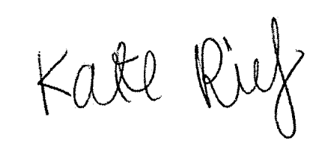
I can’t help feeling that I failed Annabelle and that this is partly my fault. Well not as much as it’s the
fault of that crazy father of hers who wouldn’t take her to the doctor.

X
Kate Riley

Brookbend Police Department
Witness Statement

Case #  20-123456 | Date of Report:  February 3, 2020 | Case Title:  Coleson Child Death
Activity: Interview statement of Dr. Joshua Sapp, Medical Examiner |  | Page Number: 1 of 2

My name is Dr. Joshua Sapp. I am the Brookbend Medical Examiner. I have held this position for the past 10 years. Prior to holding that position, I served as the Assistant Medical Examiner of Brookbend, Texas for five years. I attended the University of Texas for my undergraduate degree in pre-med and biology. I received my medical degree from Johns Hopkins. I completed training in anatomic pathology and forensic pathology from the New York University Medical Center. I am certified in both anatomic and forensic pathology by the American Board of Pathology. I am an active member of the National Association of Medical Examiners. I am licensed to practice medicine in six states, including Texas. I have performed over 2,000 autopsies.

On February 2, 2020, I conducted an autopsy of Annabelle Lee Coleson. A copy of my autopsy report is attached hereto and is a true and accurate representation of my findings.

Annabelle Lee Coleson died of untreated/undiagnosed Juvenile Diabetes which resulted in diabetic ketoacidosis (DKA). DKA is a life-threatening condition that develops when cells in the body are unable to get the sugar (glucose) they need for energy, such as when you have diabetes but do not take enough insulin. Without enough insulin, one’s body cannot use sugar for energy and when her cells did not receive sugar, her body began to break down fat and muscle for energy. This results in the production of ketones, or fatty acids, which enter the bloodstream and cause DKA.

Typically DKA can be caused by not taking enough insulin, severe dehydration, or a severe infection or other illness. It can also occur because of a combination of these issues. Both type 1 diabetics (those with little or no insulin in their bodies) as well as type 2 diabetics (those whose blood sugar levels are high) can be impacted by DKA. While symptoms can vary in diabetics, in addition to high blood sugar, some of the noticeable symptoms of DKA are:

- Flushed, hot, dry skin
- Blurred vision
- Feeling thirsty
- Drowsiness or difficulty waking up; in children there is a lack of interest in normal activities
- Rapid, deep breathing
- A strong, fruity breath odor
- Loss of appetite, belly pain and vomiting
- Confusion

Brookbend Police Department
Witness Statement

Case #  20-123456 | Date of Report:  February 3, 2020 | Case Title:  Coleson Child Death
Activity: Interview statement of Dr. Joshua Sapp, Medical Examiner |  | Page Number: 2 of 2

With severe DKA, one might have a difficult time breathing and there may be brain swelling and a risk of coma and death. DKA can be tested through blood or urine tests in a laboratory. Urine dipstick tests are available for use at home to test. Severe DKA must be treated in a hospital. The treatment involves insulin and fluids through a vein and close monitoring of chemicals in the blood. With severe DKA, it may take several days for one’s blood sugar level to return to normal.

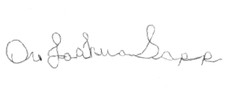
X

Dr. Joshua Sapp

Brookbend Police Department
Witness Statement

Case #  20-123456 | Date of Report:  February 7, 2020 | Case Title:  Coleson Child Death
Activity: Interview statement of Don Coleson |  | Page Number: 1 of 3

My name is Don Coleson. On February 7, 2020, I met with Detective Sergeant Amelie M. Hodges at the Brookbend Police Department in Brookbend, Texas. The following is a true and correct representation of my statements to Det. Hodges at that time:

My daughter Annabelle was four years old when she died. I am a single father. I have another daughter named Madeline who is 9 years old. My wife died two years ago of diabetes. I have raised the girls alone since that time. We live at 111 Penny Park Place in Brookbend, Texas. We are members of the First Church of the Divine Healing of Our Lord. We joined the church about three years ago. One of the central beliefs of our church is that it is God who heals illness after forgiveness and prayer for our sins. We believe that this is the only cure for illness because all illness is due to sin. This belief applies to children as well as adults.

Annabelle has always been a healthy child. She was very active. Always running and playing. She has not seen a doctor since the first year after she was born. We were not part of the church at that time and only joined around the time Annabelle turned one year old. Annabelle has never needed a doctor. My wife and I took care of her and our other daughter. We never had to do more than care for small cuts and bruises and minor colds.

I noticed Annabelle acting different about two weeks or so before she died. She was weak and tired. She drank a lot of water too and was frequently up and down at night going to the bathroom. She always seemed hungry too. But she was still moving around and she didn’t complain about feeling bad .
. . she just acted a bit more tired and less energetic. I thought she was just going through a stage, maybe a growth spurt that was dragging her down. Madeline had periods of less energy when she was around that age.

On Tuesday, January 28, 2020, I noticed that Annabelle seemed a bit more tired and weak. She lay on the couch a lot after school and her teacher sent a note home stating that Annabelle had been in the nurses office lying down for part of the day. We did go out to eat that night at Chick Fil A though and she ate chicken nuggets and fries without any problems and was very excited to be there. She seemed fine to me later that evening.

On Wednesday, January 29, 2020, I woke up around 7:00 a.m. and checked on the girls. Both were still asleep. Madeline woke up around 8:00 a.m. but Annabelle slept until 9:30 a.m. I heard Annabelle calling to me from her room. I went into her room and saw that she had kicked off
her covers. I noticed that her legs looked very skinny and slightly blue. I never realized how skinny she was. I also noticed that she was shivering. She was acting like she had a fever but I don’t think she did. She was mumbling and I couldn’t really understand what she was saying. She sounded really confused. I wrapped her up in a blanket to try to get her warm. I thought it

Brookbend Police Department
Witness Statement

Case #  20-123456 | Date of Report:  February 7, 2020 | Case Title:  Coleson Child Death
Activity: Interview statement of Don Coleson |  | Page Number: 2 of 3

was a spiritual attack so I stayed by her side and prayed non-stop. I asked Annabelle if she loved our Lord and she nodded her head yes. Her breathing was labored and she was breathing very deeply. Later I went downstairs to fix lunch for Madeline. While I was downstairs, Annabelle fell off the bed while trying to get up to go to the bathroom. At that point, I moved her downstairs to the couch so she could be near by. I fixed a fruit smoothie drink for Annabelle and she drank all of it. She drank a lot of water that day. After lunch, Madeline and I spent the afternoon kneeling by the couch praying. We slept by the couch so we could be nearby. I really didn’t see anything that raised a red flag. I really thought it was just a growing thing and that she would be better in a day or two.

On Thursday, January 30, 2020, Annabelle seemed to be better. Her breathing wasn’t quite as labored and she wasn’t shivering anymore. She had a bit of color in her cheeks. I remember that they were a brightish red. I tried to feed her some soup but she couldn’t swallow very well so I got a syringe and gave her some chicken broth through the syringe. She still didn’t eat very much and she wouldn’t drink anything. She didn’t get up all day. Her breathing stayed about the same most of the day but toward the evening it became labored again. At one point she stopped breathing but it was only for a few seconds and then she started breathing again. Overall she seemed to be getting better and I let her sleep in her own room that night.

On Friday, January 31, 2020, I woke up about 7:00 and began to get ready for work. I went in to wake up Annabelle at 7:30 and saw her trying to sit up but she just fell over back onto her bed. She was mumbling again and I couldn’t understand what she was saying. I tried to give her some water but she couldn’t swallow. She turned over and went back to sleep. At around 8:30, I went back in to check on her but she wasn’t responsive. She seemed to be in sleep mode. Around 9:00 a.m. when I still couldn’t wake her up, I called our friend and fellow church member Diane Reagan and asked her to come over because Annabelle wouldn’t wake up. I asked her how I could get her to drink water and Diane said I should give her water through a syringe. Diane said she would call our church prayer chain and get people to come over to the house to pray. Diane said she would be there as soon as she could. Diane arrived about 10:00 and began making phone calls to church members and our pastor. By 2:00 p.m., probably 20-30 church members came to our house to pray. It probably wasn’t enough and that is why Annabelle died. We needed more help.

Around 3:00 p.m., Annabelle stopped breathing for a brief moment. Diane Reagan asked me if I didn’t think I should call an ambulance and have her taken to the hospital. I knew that was not necessary because our Lord would heal her. My pastor backed me up. At around 3:45 or 3:50 Annabelle stopped breathing for a longer period of time. I called 911 at 4:00 when she didn’t

Brookbend Police Department
Witness Statement

Case #  20-123456 | Date of Report:  February 7, 2020 | Case Title:  Coleson Child Death
Activity: Interview statement of Don Coleson |  | Page Number: 3 of 3

start breathing again but as I was on the phone with 911 an ambulance showed up at the house. I guess someone else called them.

Yes, Annabelle’s teacher, Kate Riley told me that she was concerned about Annabelle. She sent a couple of notes home and called me once. She can be like a dog with a bone. I told her that it was probably just a growth spurt that was getting Annabelle down and in a few days or a week she’d be back to normal. She suggested that I give Annabelle Pedialyte but that would be like giving up on our faith. It would not be trusting in our Lord to give something like that.

I never considered taking Annabelle to see a doctor or giving her any sort of medication over the last
two weeks before she died. She just didn’t seem that sick to me. I didn’t understand how sick she was. Even though my wife had died the circumstances weren’t the same. I had never seen anything happen like this and I just didn’t know what to do other than pray. I thought Annabelle’s illness was a spiritual
attack and that our prayers would be enough. Our religion teaches that any health problems, any illness can only be cured by our Lord. I knew my faith was her only salvation and chance for healing. I know healing can only come from our Lord. I just didn’t know she was that close to death. I did try to save her. At the end, I did call 911 and I tried to give her CPR but that was when the ambulance showed up and took her away. In the end, I turned my back on our faith and tried to save her on my own, and I lost my baby. Our Lord is the only one who can heal the sick. I believe it is possible that our Lord just might bring her back to us if we pray hard enough.

X
Don Coleson

Brookbend Police Department
Witness Statement

Case #  20-123456 | Date of Report:  February 9, 2020 | Case Title:  Coleson Child Death
Activity: Interview statement of Reverend Shorty McGee |  | Page Number: 1 of 3

My name is Reverend Shorty McGee. I am the head pastor of the First Church of the Divine Healing of Our Lord in Brookbend, Texas. On February 9, 2020, I met with Detective Sergeant Amelie M. Hodges in my office at the church. The following is a true and correct representation of my statements to Det.
Hodges at that time:

I have an Associate’s Degree from Texas Community College in mechanics and wood working. I graduated in 1981. I worked odd jobs for about five years before I felt a call to the ministry. I began working as a mechanic during the day while studying the scriptures and religious books at night. After another couple of years, I felt ready to enter the ministry and began holding small religious services in my home or in the homes of others. Eventually, the group of people who were coming to my services suggested that we form an official church. I was already preaching from the teachings of the Divine Healing of Our Lord denomination so we applied to them for a charter and it was granted. I have been the pastor of the First Church of the Divine Healing of Our Lord for the past 30 years. I did not attend seminary. I am self taught in the divine scriptures though I have attended religious courses offered by our denomination’s leadership. My particular field of study focus has been healing through faith. Over the last 15 years, I have taken two to three courses per year through our denomination on prayer, praise and healing and on the divine Biblical scriptures that address healing. Additionally, I have up to ten speaking engagements around the country each year on the subject of faith healing. Despite my lack of formal education, I am considered one of the foremost pastors on divine healing through faith.

I am very familiar with the Coleson family. Approximately four years ago they joined our church. I do not believe that they had been particularly religious before that. I came to know them very well. The
girls were part of our children’s program that my wife leads and Mr. and Mrs. Coleson were in one of my Bible Study classes. They were a wonderful couple... always volunteering to help out financially, leading Bible study groups, hosting events in their home and being on the front lines praying whenever a fellow member needed assistance. They recruited heavily for others to enter our church family. It was a sad day when Karryn Coleson died. Our church family lost a wonderful church member and the Coleson family lost a wonderful wife and mother.

I became aware that Annabelle was ill on January 29, 2020 when I received an e-mail from Mr. Coleson asking that the prayer chain be activated and that his fellow believers join together in prayer for his dear daughter. I activated the prayer chain and sent Don an e-mail of comfort and blessings. My wife and I prayed throughout the weekend for Annabelle. The Coleson’s were not at church on Thursday but our
whole congregation prayed for Annabelle’s healing.

Brookbend Police Department
Witness Statement

Case #  20-123456 | Date of Report:  February 9, 2020 | Case Title:  Coleson Child Death
Activity: Interview statement of Reverend Shorty McGee |  | Page Number: 2 of 3

On Friday, January 31, 2020, I received a call from fellow church member Diane Reagan. Ms. Reagan told me that she was at the Coleson home and that I should come immediately. She said that she had activated the prayer chain and that church members were arriving in droves. Our church is just that way. Always willing to help. Diane told me that Annabelle was not responsive and would not wake up. I told Diane to start praying and miracles would happen. I hopped in my car and headed to the Coleson home.

At about noon when I arrived at the Coleson’s house, I was gratified to see it filled with church
members. All praying and singing… rejoicing in the healing that was to come. I gathered a group of men and headed to Annabelle’s room for a prayer circle. We gathered around Annabelle’s bed and spent the afternoon praying for healing and forgiveness of Annabelle’s sin. Annabelle stopped breathing a few times but we just prayed harder and she always started breathing again.

I guess it was around 3:00 when she stopped breathing for more than a few seconds. Ms. Reagan began to panic and said we should call for a doctor. I reminded Ms. Reagan that only our Lord can heal because only our Lord can take away sins. To call a doctor would be to spit in the face of all that we believe and to show a lack of faith, risking the life of poor Annabelle. Mr. Coleson agreed and told her that this was just a test of his faith and he would pass the test.

At around 4:00, Annabelle had stopped breathing for quite a while. Mr. Coleson succumbed to fear and lack of faith and called 911. It appears that someone else had already called because the
ambulance was arriving as he was calling. It was a lack of faith that killed Annabelle and not a lack of medical attention. Calling 911 was a signal that we no longer relied on our Lord’s healing power and no longer believed that He would provide healing and forgiveness. That is why that poor child died.

After Annabelle’s death, I learned that she had been sickly for the past two weeks. Mr. Coleson told me that he honestly believed it was just growing pains and nothing more that was making her run down. He said she kept getting more lethargic and wouldn’t eat or drink over the week prior to her death. I asked him why he didn’t ask for prayer before Saturday or get a prayer circle together before the day she died. He said he thought he could handle it himself and that he and Madeline had been praying. He told me he believed our Lord would heal her. If only he had called me sooner, we could have got to praying sooner and maybe things would have turned out differently.

People can scoff at our beliefs but I tell you that they are founded on the solid Word of our Lord. We believe that only the King James version of the Bible is the true and holy divine Word of our Lord and the scriptures are clear that healing comes through prayer and salvation. It is impossible to get out from under illness and disease – basically curses – except through the Words of our Lord found in the divine Holy Scriptures. Our Lord can be merciful but there is no way to guarantee our Lord’s deliverance from

Brookbend Police Department
Witness Statement

Case #  20-123456 | Date of Report:  February 9, 2020 | Case Title:  Coleson Child Death
Activity: Interview statement of Reverend Shorty McGee |  | Page Number: 3 of 3

the curse for those who do not walk in His Words. I don’t see any doctors in the scriptures. Do you? There is a reason for that. Our Lord doesn’t command us in His divine scriptures to send people to see doctors. He commands us to meet their needs by praying for them. He commands that we be faithful. Now, I’m not against doctors nor is anyone in our church. There is a place for them for those who place their faith there. But let’s face it, doctors are more dangerous than gun owners and the very fact that the word pharmacy was derived from a Greek word meaning witchcraft or sorcery, should tell you all you need to know. The statistics show how dangerous doctors and hospitals are. I wrote a book on this very subject called “Physicians of Death.” Research shows that:

- 12000 deaths/year from unnecessary surgery
- 7000 deaths/year from medication errors in hospitals
- 20000 deaths/year from other errors in hospitals
- 80000 deaths/year from nosocomial infections in hospitals
- 106000 deaths/year from non-error, adverse effects of medications

This is 225,000 deaths per year resulting from “modern medical care.” The figures are probably even
higher by now. The research I based my book on is in part from a wonderful treatise called “Is US Health Really the Best in the World.” It is a wonderfully well written and well researched article that I believe makes my point.

"The Holy divine scriptures are clear that we are to put our trust in our Lord only and we can only do this through repentance and faith in his promises. You just can’t argue with the Holy divine scriptures. There is example after example of the foundation of our faith and our hope. In Luke 13:10-16, Jesus was teaching in the synagogue and there was a woman there who had been crippled for 18 years. Jesus laid his hands on her and immediately she was healed and glorified God. In Matthew 17:15-18, Jesus healed a boy who was having seizures. He told his father to bring the boy to him and when he did, Jesus cast the devil out of the boy and he was healed. In Mark 1:29-34, we are told that Jesus went to the house of Simon and cured his mother who was ill with a fever. That night after sunset people from all over the city began bringing all the sick to Him and Jesus healed people with many diverse diseases and also cast out demons."

Don’t you see? Our Lord didn’t send the sick and diseased to see the local doctor. He healed the
diseased but he didn’t just heal them, he delivered them from the spirit that made them sick. You can’t
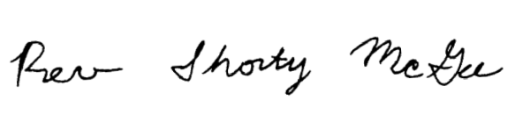
argue with success and our Lord has shown that he has the sole authority over healing.

X
Rev. Shorty McGee

Brookbend Police Department
Witness Statement

Case #  20-123456 | Date of Report:  February 8, 2020 | Case Title:  Coleson Child Death
Activity: Interview statement of Diane Reagan |  | Page Number: 1 of 2

My name is Diane Reagan. On February 8, 2020, I met with Detective Sergeant Amelie M. Hodges at my residence of 200 Penny Park Blvd. in Brookbend, Texas. The following is a true and correct representation of my statements to Det. Hodges at that time:

I was at the Coleson residence located at 111 Penny Park Place on January 31, 2020 from approximately 10:00 a.m. until the officers arrived in response to the 911 call. I responded to an urgent call from Mr. Coleson at 9:00 a.m. that morning that Annabelle appeared to be in a coma state but that she was still breathing. I asked Mr. Coleson if Annabelle had been running a fever and he said that to his knowledge Annabelle had not. He also told me that Annabelle had never complained of being sick. Mr. Coleson
told me that Annabelle was not moving, had shallow breathing and that she hadn’t been talking since
the day before. He asked me what he should do right now because Annabelle seemed to be very dehydrated. I advised him to use a syringe to put water into Annabelle’s mouth and told him that I would be over as soon as I could. Mr. Coleson and I both live in Penny Park Estates but on different
streets. As soon as I got ready, I walked to Mr. Coleson’s house. When I arrived, I saw that Annabelle was lying in her bed and was not moving and was not responsive to touch or to words. She was breathing although her breathing was shallow.

I am a member of Mr. Coleson’s church, First Church of the Divine Healing of Our Lord. Mr. Coleson and I attend the same Bible study and church services. A key tenant of the church is the belief that physical illness in an individual is due to sin and the only way to cure that illness is to ask for forgiveness and pray that God will cure you from that illness. This applies to both children and adults.

Upon arriving at the house and seeing Annabelle, I immediately activated our Church prayer chain and asked members to come to Mr. Coleson’s house to pray over Annabelle. Within a couple of hours 20 to 30 church members, including our pastor, had arrived at the Coleson house. We spent the day praying over Annabelle and rejoicing in God’s eventual healing of her. I guess my faith is not as strong as the other members of the church because around 3:00 I became very scared when Annabelle stopped breathing for a brief moment. I begged Mr. Coleson to seek medical help. Pastor McGee rebuked me though and I began praying again. Mr. Coleson told me that this was a test of his faith and Pastor McGee backed him up. I really should have known better. We have seen miraculous examples of healing in our church. Just last month, we had two members on the edge of death who were prayed back to health. We prayed for her but I guess God decided he needed her in Heaven.

Brookbend Police Department
Witness Statement

Case #  20-123456 | Date of Report:  February 8, 2020 | Case Title:  Coleson Child Death
Activity: Interview statement of Diane Reagan |  | Page Number: 2 of 2

Just before 4:00 p.m. though Mr. Coleson did call 911 and request an ambulance. Annabelle had stopped breathing again. Mr. Coleson went into a panic and grabbed Annabelle and kept yelling “My baby, my baby. I can’t lose you. I lost your mom. I can’t lose you too. We prayed and prayed for you. Why aren’t you healed?” He truly believed that prayers would heal Annabelle. He didn’t understand why they didn’t and neither do I.

I was friends with Mr. Coleson’s late wife and friends with him. We are not in a relationship. We are only friends and have only ever been friends. I loved his late wife dearly. I have known Mr. Coleson for approximately 3 years. He and his wife are the people who introduced me to the church and helped me to understand how important faith is. They helped me when I lost my job two years ago by giving me a loan and helping me to find other work. I am very grateful to Mr. Coleson. At times I babysit Mr.
Coleson’s children when he has to work late.

I know the Coleson family very well. Mrs. Coleson was a wonderful wife and mother and she truly believed in the power of prayer in healing. She would have supported Mr. Coleson 100% in the decisions he made with Annabelle because those decisions came from a place of love and faith. The Colesons are a loving family and Mr. Coleson is a great dad. He is a hard worker but he always makes time for his girls. Mr. Coleson always has his childrens’ best interest at heart. He talks about those girls all the time and I’ve seen him struggle to provide them with a good life, trying to be both father and mother to the girls. He loves those girls and would do anything for them. He would not deliberately hurt them. He would never think of doing anything that might cause harm to Annabelle and
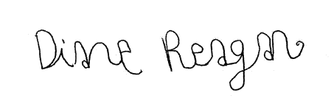
Madeline. What happened is a tragedy and he is truly broken over Annabelle’s death. This is just a witch hunt and he is being persecuted for his faith. It is shameful for the police and the district attorney to be persecuting Mr. Coleson. They need to let him and Madeline grieve in peace.

X
Diane Reagan

Brookbend Police Department
Witness Statement

Case #  20-123456 | Date of Report:  February 9, 2020 | Case Title:  Coleson Child Death
Activity: Interview statement of Madeline Coleson |  | Page Number: 1 of 2

My name is Madeline Coleson. On February 9, 2020, I met with Detective Sergeant Amelie M. Hodges at my home in Brookbend, Texas. The following is a true and correct representation of my statements to Det. Hodges at that time:

My daddy is Don Coleson. My mommy was Karryn Coleson. She died two years ago. I live with my daddy and my sister Annabelle in Brookbend, Texas. I go to school at Brookbend Elementary School. I go to church at the First Church of the Divine Healing of Our Lord. We have gone to church there for about three years.

I don’t go to the doctor. When I was little I used to go when I was sick but when we joined the church we stopped going to the doctor. Daddy teaches us that when you get sick that means you sinned and God will heal you if you pray hard enough and believe and if enough people pray with you. I guess mommy didn’t pray enough. It makes me sad sometimes to think about her but I know that daddy loves me and Annabelle very much. He always plays with us and takes care of us. When we are sad he holds us and he listens to what we have to say. Whenever we don’t feel good, daddy always holds our hands and prays for us. He is a good daddy.

Annabelle was 4. She died last week and went to heaven. I liked to play with Annabelle. We would run races and swing and play on the slides. She hasn’t been feeling good though. I don’t know how long. It seemed like a long time. She was sick at school last week and sat in the teacher’s lap most of recess. She was sick before that day too. She had been sick for a while. Annabelle was usually never sick though. I got sick sometimes but Annabelle was always well. She just started acting tired all of a sudden. She lay around and wouldn’t play with me. She wouldn’t talk to me either. She sounded sick when she tried to talk like she didn’t have any air. She slept all the time and when she was awake she drank a lot of water and always went to the bathroom. Daddy said she would be fine though and we prayed with her every night so God would heal her.

A few days before she died, Annabelle came home from school and laid on the couch. She had been sick at school that day. I heard her teacher tell the nurse that she was going to get the state to take me an
Annabelle away from our daddy if he didn’t do something. I was really scared because I love my daddy and he loves me. I don’t want to go away. I told Annabelle that she had to get better or the teacher was going to get us taken away. We were both really scared and Annabelle cried. I told her she had to pretend to be well. Annabelle got up and went to eat with us that night and pretended to feel better so Daddy wouldn’t know she was sick.

The next day I woke up and watched cartoons. Annabelle was still asleep. Later, I heard Annabelle calling daddy and I followed him to her room. Annabelle was acting really cold. She was shaking but daddy wrapped her up in a blanket to get her warm. Daddy said that we just had to pray harder and that he was going to have Pastor McGee get everyone in the church praying for Annabelle. Daddy went to fix me lunch and Annabelle fell out of bed. Daddy came upstairs and got Annabelle and put her on

Brookbend Police Department
Witness Statement

Case #  20-123456 | Date of Report:  February 9, 2020 | Case Title:  Coleson Child Death
Activity: Interview statement of Madeline Coleson |  | Page Number: 2 of 2

the couch so she would be near us. Daddy and I prayed for Annabelle all afternoon. When daddy went to e-mail the pastor, I reminded Annabelle that she had to get well or we couldn’t live with daddy anymore. Annabelle asked daddy for a smoothie and she drank it all up. I slept by the couch that night.

We didn’t go to church on Thursday even though Annabelle felt better. She stopped acting cold and she ate some soup though daddy had to feed it to her in a funny tube. I got scared later that day though when daddy started crying and saying “my baby stopped breathing. What do I do?” But Annabelle must have been getting better from all the prayers because daddy let her sleep in her own room that night.

On Friday morning, daddy told me that me and Annabelle didn’t have to go to school that day because Annabelle wasn’t all the way better. Daddy said that Annabelle was sleeping and wouldn’t wake up. I was really scared because daddy was crying and praying and rocking Annabelle and begging her to wake up. He kept saying, “what do I do? What do I do?” Then he called Miss Diane and asked her to come over and help. Miss Diane came to our house and called all the church members to come over and pray. A lot of people came to our house and everyone was praying and singing and talking about how Annabelle would be all better soon if we just had faith.

I wasn’t allowed in Annabelle’s room that afternoon but I could hear some of what was happening. Miss Diane was crying and begging my daddy to call an ambulance but pastor McGee told her that she needed the devil to flee from her. He said that my daddy knew that only God could heal Annabelle and it would be evil for him to call a doctor. He said my daddy would lose his faith if he called a doctor.

Annabelle’s teacher called right about then and I talked to her on the phone. I told her that Annabelle hadn’t been out of bed or awake all day and that she wouldn’t eat or drink. I said that daddy was giving Annabelle water through the funny tube and that Annabelle was asleep and wouldn’t wake up. I told her not to worry though because our church friends were at my house and were praying and singing and that they said Annabelle would wake up and start breathing again any minute. Annabelle’s teacher hung up on me and a few minutes later an ambulance and the police came to our house. Right before the ambulance came, I heard daddy talking on the phone, crying and saying he needed help because his baby wasn’t breathing anymore.

I think my daddy did the right thing by praying for Annabelle instead of going to the hospital because God created everyone and how can we be more powerful than God? He is the one that is in control. I believe that and so does my daddy. We always go to Him with our problems because He is the One in charge. He decides how things work. How can a doctor be more powerful than God?

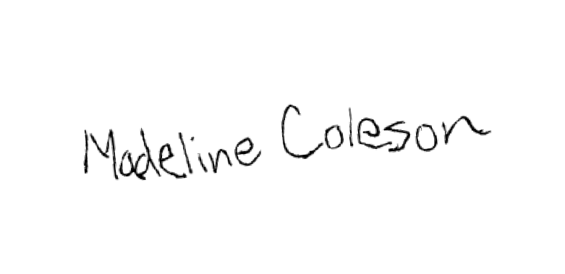
I don’t understand what happened and why Annabelle had to go to heaven except that it must have been God’s choice. We prayed for her but I guess God decided he needed her in Heaven.

X _ Madeline Coleson

EXHIBITS

-----Original Message-----
From: Shorty McGee <revshortymcgee@coldmail.com> To: Don Coleson <colesondad@coldmail.com>
Sent: Wed., Jan 29, 2020 4:45 pm
Subject: Prayer Chain Request Activated

Lord, we thank You for having mercy on Your dear child Annabelle and for comforting her father during this trial of his faith. We thank You Father for giving Don the faith to hold fast to the confession of his hope and that it waiver not, for it is Your will Lord that Annabelle was already healed, 1 Peter 2:24 - - “Who his own self bare our sins in his own body on the tree, that we, being dead to sins, should live unto righteousness: by whose stripes ye were healed.”
We add our faith to Don’s and command Annabelle to be healed. We command that spirit of infirmity to loose Annabelle now, leave her body, leave her home, and go back from where it came and stay there.
We stand on the word, Mark 11:24 – “Therefore I say unto you, What things soever ye desire, when ye pray, believe that ye receive them, and ye shall have them.”
Matthew 18:18-20 – “Verily I say unto you, Whatsoever ye shall bind on earth shall be bound in heaven: and whatsoever ye shall loose on earth shall be loosed in heaven. Again I say unto you, That if two of you shall agree on earth as touching any thing that they shall ask, it shall be done for them of my Father which is in heaven. For where two or three are gathered together in my name, there am I in the midst of them.”
James 5:14-16 - Is any sick among you? let him call for the elders of the church; and let them pray over him, anointing him with oil in the name of the Lord: And the prayer of faith shall save the sick, and the Lord shall raise him up; and if he have committed sins, they shall be forgiven him. Confess [your] faults one to another, and pray one for another, that ye may be healed. The effectual fervent prayer of a righteous man availeth much.
We pray in the name of Jesus Christ, our only hope. Amen. Be Blessed Reverend McGee.
-----Original Message-----
From: Don Coleson <colesondad@coldmail.com> To: Shorty McGee revshortymcgee@coldmail.com

Sent: Wed., Jan 29, 2020 3:00 pm
Subject: Help my daughter needs emergency prayer!!!

Please activate the prayer chain. I need agreement in prayer over my daughter who is very weak and pale at the moment with hardly any strength – struggling to breathe. Has stopped breathing once for a short period of time. Call me at 817-555-1213.

Blessings in Faith, Don Coleson.

FROM THE DESK OF KATE RILEY
January 19, 2020

Mr. Coleson:
I am concerned about Annabelle’s behavior and appearance recently at school. Typically Annabelle is a lively little girl and has difficulty settling down and listening in class. She is typically very talkative and active during playtime. This week however, Annabelle has been unusually quiet. She does not talk much during the day and during recess, rather than run and play with the other children; she will sit or lie down next to me on the bench. She also does not want to participate in physical education activities or classroom games and has said several times that she is tired. This sort of behavior from Annabelle is very unusual. I sent Annabelle to the school nurse today when she complained of not feeling well, and it is the suggestion of the nurse that you should have Annabelle checked out by your family physician.

Please let me know if you have any questions or if I can provide you or your family doctor any more information about what I have observed at school.

Sincerely,
FROM THE DESK OF KATE RILEY
January 28, 2020

Mr. Coleson:
As you know, I am very concerned about Annabelle’s health. Annabelle was extremely tired and weak today. She was lethargic, would not go out and play and would not eat lunch. After we spoke this morning and I asked you to come pick up Annabelle and you stated that you would pick her up after school, I sent Annabelle to the nurse’s office. Annabelle spent the day sleeping in the nurse’s office. It is my opinion that something is seriously wrong with Annabelle. This is based on my observations of Annabelle over the past two weeks, in particular her tiredness, weakness, failure to eat, excessive thirst and trips to the bathroom, and her clear loss of weight. Annabelle’s condition has only worsened over the last two weeks and in particular over the past few days. As I told you when we spoke on the phone earlier this week, Annabelle needs to see a doctor. I hope that you will ensure that she sees a physician immediately.
r t

Sincerely,

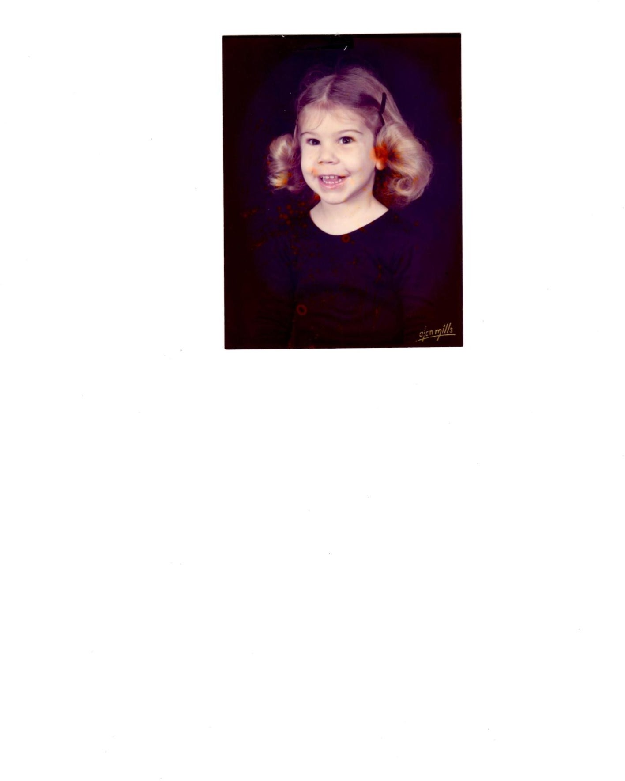

REPORT OF AUTOPSY

Decedent | Age | Birth Date | Race |  | Sex | Case No
Annabelle Lee Coleson | 4 | March 31, 2015 | C |  | F | 20-123456
Type of Death | Means |  | ID By | Authority for Autopsy
Natural | untreated and undiagnosed illness |  | Toe tag | State of Texas
Present at Autopsy

Det. Sergeant Amelie M. Hodges

FINDINGS

- Metabolic death – diabetes
  - Laboratory records indicating diabetic illness

Physical wasting, severe
- Posterior callous rib lesions, consistent with remote fractures
- No acute physical trauma identified
- Based upon the severity of the condition, Annabelle must have been sick for at least 30 days prior to her death.

The death is due to untreated diabetes.

Comment: The case was reviewed by Joshua Sapp, M.D.

CAUSE OF DEATH: Diabetic Keto Acidosis
Untreated Juvenile Onset Diabetes

The facts stated herein are true and correct to the best of my knowledge and belief.
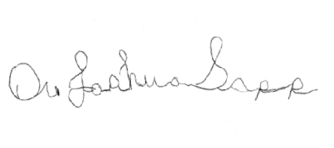
Brookbend Medical
Examiners Complex
February 2, 2020
9:55 a.m.
Joshua Sapp, M.D., Chief Medical Examiner
Location of Autopsy
Date and Time of Autopsy

EXTERNAL EXAMINATION

DESCRIPTION
Height | Weight | Eyes | Hair | Rigor | Livor | Body Heat
37” | 28 lbs | Brown | Brown | 0 | 1 | Warm

Pronounced: 4:50 p.m. January 31, 2020
Dispatch Notified: 3:56 p.m. January 31, 2020
M.E. Notified Yes
Body Found by: Family
Body Viewed by M.E.? Yes

Description of Clothing:

Long pink nightgown with blue and green flowers

Scene Description:

Annabelle Lee Coleson had reportedly not been feeling well for approximately two weeks. According to reports, she was tired, lethargic, eating poorly, drinking excessive amounts of water and frequent urination. On Wednesday she ate very little and was lethargic. She was noticed to be shivering and her breathing was labored. On Thursday, she appeared to be somewhat better; however her breathing was still labored and at one point she stopped breathing. On Friday, Annabelle was unable to sit up or speak coherently and then lapsed into a coma. At some point, a family member contacted 911 emergency services and sent an ambulance to Annabelle’s home. Reportedly the father had declined to seek medical attention for Annabelle because of their religious beliefs. Though, dispatch did receive a 911 call from Annabelle’s residence around 4:00 p.m. on Friday. The report at that time was that Annabelle was no longer breathing. EMS responded to the Coleson home and found that Annabelle did not have a pulse and was not breathing. CPR was started and later Advanced Cardiac Life Support. She was then transported to Brookbend Hospital. Resuscitation efforts were not successful and Annabelle was pronounced dead at 4:50 p.m. Emergency staff obtained Blood and urine during resuscitation and laboratory analysis indicates that Annabelle was in Diabetic Keto Acidosis, which caused her death.
Annabelle had juvenile onset diabetes mellitus and had likely been having symptoms for several weeks or months; however she was not provided medical attention until she was dead.

Upon my arrival at the emergency room, I observed the body of Annabelle Coleson. The body was noted to be very emaciated. She also appeared to be dehydrated. There were signs of medical intervention present, including IV lines, monitor/defib pads, endotracheal tube, nasogastric tube. The family was allowed to spend time with the body for grieving purposes. I asked Mr. Coleson about a funeral home and he responded “We won’t need one. She will be alive tomorrow.” When I advised the father that the body would be taken to my office for an autopsy, he responded “You won’t need to do
that, she will be alive by then.” I did not speak to the father any further. The body was taken to the

morgue and secured by security officers. I obtained vitreous from the body for further analysis. On February 2, 2020, myself and Det. Sergeant Amelie Hodges transported the body to my office for autopsy. I performed the autopsy and Det. Sergeant Hodges was present and witnessed the entire autopsy procedure. The body was left in the morgue so that that a pediatric skeletal trauma survey could be completed.

Body Examination:

The body presented supine on a hospital emergency room bed in room 5 of the Brookbend Hospital Emergency Room. The body is that of a Caucasian female in an emaciated state. Estimated weight is approximately 32 pounds. This is underweight for standard height/weight for a typical four-year-old female. She has brown hair and brown eyes. Her skin appears and feels dry, skin turgor demonstrates dehydration. ER personnel report that it was difficult to obtain blood specimens for laboratory analysis and only a small quantity was drawn. A small amount of urine was obtained via catheterization and was sent for analysis. Hospital laboratory findings demonstrate severe Diabetic Keto Acidosis, severe hyperglycemia, and that this has been a chronic condition. This child has a general appearance of emaciation, malnutrition, dehydration and chronic untreated illness. While it is possible, it is however unlikely that Annabelle showed no symptoms of the disease. The process of the illness would have occurred over time. Annabelle was dehydrated and essentially starving to death, not because she did not receive food but because the diabetes would not allow her to carry food to her tissue. Basically all body function stopped as she became dehydrated and her muscle, lung and heart function became impaired.

Medical History:

Unknown

Medications/Doctor:

Unknown

Toxicology Results:

Vitreous sent for electrolyte analysis, blood sent for comprehensive drug screen. Pediatric skeletal trauma survey done.

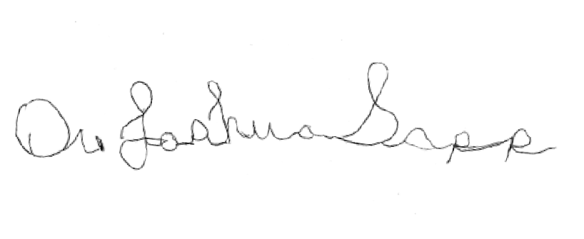
X
Joshua Sapp, M.D. Chief Medical Examiner

